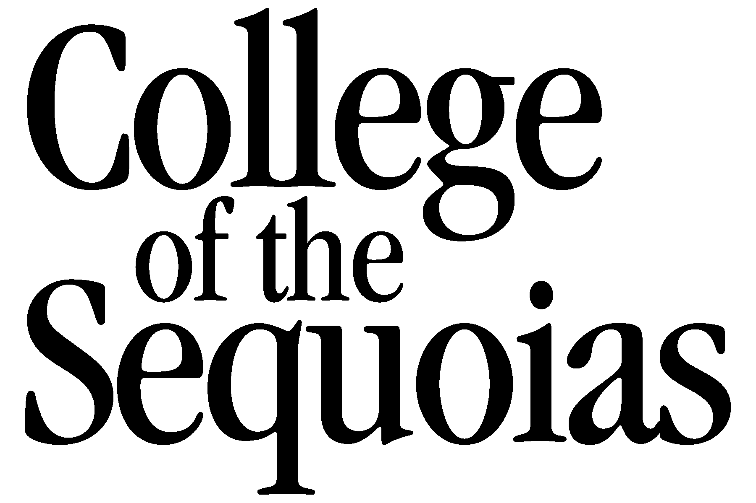 | Request for Approval  of Credit for Salary Advancement  COSTA MA 9.2.2.4
This request must be submitted at least one (1) week prior to beginning of course/workshop/work experience.
Name: |  |  |  |  |  | Date of Request:
Please check the appropriate category |  |  |  | Academic Course Seminar, Workshop or Clinic Employment
Approval is requested for the following to apply toward advancement in salary class.
Note: College units must be from an institution accredited by the Western Association of Schools and Colleges or the equivalent.
Course Number: Title; Seminar; Workshop; Employment; Licensure Category |  |  | Units  or  Hours |  | College, Institution, Agency  or  Employer |  | Dates of Credit Experience  (include completion date if available)
Justification: Include a description of courses; seminars; workshops; clinics; employment; and you must show relationship to contractual assignment (include attachments) which validate this credit.
Upon completing the above information, deliver this form to Human Resource Services for routing to the Committee.
Action on Request
Prior approval is required for credit for salary progression. (Section 9.2.2.4 COSTA Master Agreement)
Approved |  | Denied |  | Date |  | Committee Member’s Signature
Justification for Decision
Original –– Human Resource Services
Second –– Committee for Consideration of Credit
Third –– Originator HR:/tmp/in/input.doc

